Branch: MCA (Data Science) Kargil | Semester: 2nd
Student Name: Kunal Gupta | UID: 25MCD10013
Subject Name: Technical Training - I Lab | Subject Code: 25CAP-652
Section/Group: 25MCD KAR-1 | Date of Performance: 27-02-2026

Experiment 6
- Experiment Aim: Learn how to create, query, and manage views in SQL to simplify database queries and provide a layer of abstraction for end-users.
(Company Tags: Amazon, Zoho, ServiceNow)
- Tools used: PostgreSQL

- Objectives:
- Data Abstraction: To understand how to hide complex table joins and calculations behind a simple virtual table interface.
- Enhanced Security: To learn how to restrict user access to sensitive columns by providing views instead of direct table access.
- Query Simplification: To master the creation of views that pre-join multiple tables, making reporting easier for non-technical users.
- View Management: To understand the syntax for creating, altering, and dropping views, as well as the naming conventions required for efficient data access.

- Theory: A View is essentially a virtual table based on the result-set of an SQL statement. It does not contain data of its own but dynamically pulls data from the underlying "base tables".
- Simple Views: Created from a single table without any aggregate functions or grouping. These are often updatable.
- Complex Views: Created from multiple tables using JOINs, or including GROUP
BY and aggregate functions. These provide a consolidated summary of the database.
- Security Layer: In enterprise environments, views are used to grant permissions on specific subsets of data. For example, a "SalaryView" might exclude the "Employee_SSN" or "Home_Address" columns for privacy.
- Benefits: They simplify the user experience, ensure data consistency across reports, and reduce the risk of accidental data modification by providing read-only abstractions.
4. Experiment Steps:
Step 1: Creating a Simple View for Data Filtering
Query:
-- Query 1

-- Create Student table
CREATE TABLE IF NOT EXISTS Student (
StudentID INT PRIMARY KEY,
StudentName VARCHAR(50),
Marks INT,
EnrollmentStatus VARCHAR(20)
);

-- Insert sample data
INSERT INTO Student VALUES (201, 'Arjun', 78, 'Enrolled')
ON CONFLICT (StudentID) DO NOTHING;

INSERT INTO Student VALUES (202, 'Sneha', 85, 'Dropped')
ON CONFLICT (StudentID) DO NOTHING;

INSERT INTO Student VALUES (203, 'Ritika', 91, 'Enrolled')
ON CONFLICT (StudentID) DO NOTHING;

-- Create View to show only Enrolled Students
CREATE OR REPLACE VIEW EnrolledStudents AS
SELECT StudentID, StudentName, Marks
FROM Student
WHERE EnrollmentStatus = 'Enrolled';

-- Query the View
SELECT * FROM EnrolledStudents;SELECT *
- Output:
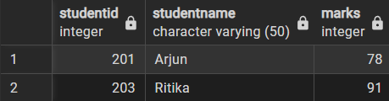
Step 2: Creating a View for Joining Multiple Tables
Query:
-- Query 2
-- Create Course table
CREATE TABLE IF NOT EXISTS Course (
CourseID INT PRIMARY KEY,
CourseName VARCHAR(50)
);
-- Insert sample courses
INSERT INTO Course VALUES (501, 'Computer Science')
ON CONFLICT (CourseID) DO NOTHING;
INSERT INTO Course VALUES (502, 'Mathematics')
ON CONFLICT (CourseID) DO NOTHING;
INSERT INTO Course VALUES (503, 'Physics')
ON CONFLICT (CourseID) DO NOTHING;
-- Add CourseID column to Student table
ALTER TABLE Student
ADD COLUMN IF NOT EXISTS CourseID INT;
-- Assign courses to students
UPDATE Student SET CourseID = 501 WHERE StudentID = 201;
UPDATE Student SET CourseID = 502 WHERE StudentID = 202;
UPDATE Student SET CourseID = 503 WHERE StudentID = 203;
-- Create View joining Student and Course
CREATE OR REPLACE VIEW StudentCourseView AS
SELECT
s.StudentID,
s.StudentName,
s.Marks,
c.CourseName
FROM Student s
JOIN Course c
ON s.CourseID = c.CourseID;
-- Query the View
SELECT * FROM StudentCourseView;

- Output:
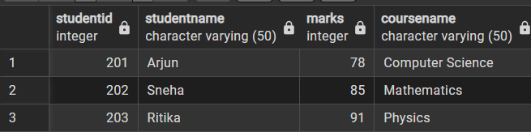
Step 3: Advanced Summarization View
Query:
-- Query 3
-- Create summarization view showing course statistics
CREATE OR REPLACE VIEW CourseSummaryView AS
SELECT
c.CourseName,
COUNT(s.StudentID) AS TotalStudents,
AVG(s.Marks) AS AverageMarks,
SUM(s.Marks) AS TotalMarks
FROM Student s
JOIN Course c
ON s.CourseID = c.CourseID
GROUP BY c.CourseName;

-- Query the View
SELECT * FROM CourseSummaryView;
Output:
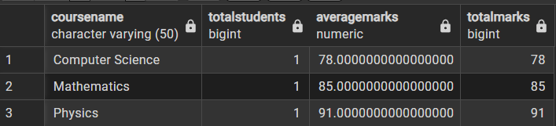
5. Learning Outcomes:
- Created and use simple views to filter and present specific subsets of data.

- Constructed join-based views to combine related tables into meaningful structured output.

- Built aggregate views using COUNT, AVG, and SUM to generate summarized statistics.

